Vanina Stagno Piantanida

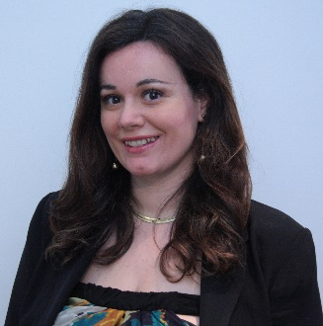

Bio:
I am Chartered Accountant and Finance Professional with 15+ year experience, acquired in International Audit firms and Finance and Accounting boutique firms in Milan and London.
I manage my own consultancy firm since 2015. I am CFO of an Hr tech startup since 2020.
I graduated in Economics and Finance in 2004, hold a Master Degree in Finance.
I live in Milan with my family and 2 kids, I love art & theatre, travelling and outdoor activities (maybe as a change of perspective from the all the figures I work with!).
I joined PWN Milan in 2015, and participated in 2 editions of the Mentoring Program, both as mentee and as a mentor. I am part of Equal Opportunities Commission of my Profession in Milan since 2012.
A full resume is attached to the present document.
Motivations to become a Board Member, Goals and Visions for the Role
I firmly believe in Pwn core values about professional women empowerment. More generally, I believe that a more diverse society in term of leadership roles and professional roles can benefit everyone.
Since my teenager years, I enrolled in associations with similar goals, trying to do part in reducing global gender gap in the professional area of life. One way in which we can do so is through professional non technical education, therefore developing our soft skills, one of the main goals of PWN.
I have been a PWN member since 2015: my main aspirations have been professional networking and developing of soft skills, both of which I have found fulfilled joining the Association. I participated in 2 Mentoring Program editions which were part of my giving back to other members. And the board membership will be another active role in applying values I believe in.
If I became part of PWN board, apart from executing my tasks as Treasurer, I would like to care about increasing small entrepreneurs and Tax and Legal Professionals participation and memberships in PWN.
Those are the background from where I came from, and even if most of the Professionals there are highly trained, many may have areas of improvement into their soft skills.
Other 2 areas of interventions that I would like to improve are the intersections with the digital sector, which is obviously becoming more and more present in our everyday lives and a profitable cooperation with other Associations who have similar goals with PWN, in order to maximise the awareness of our message into public.
I look forward to join the board!

